DUAL PURPOSE - CEILING SCREWS COLLATED AND LOOSE

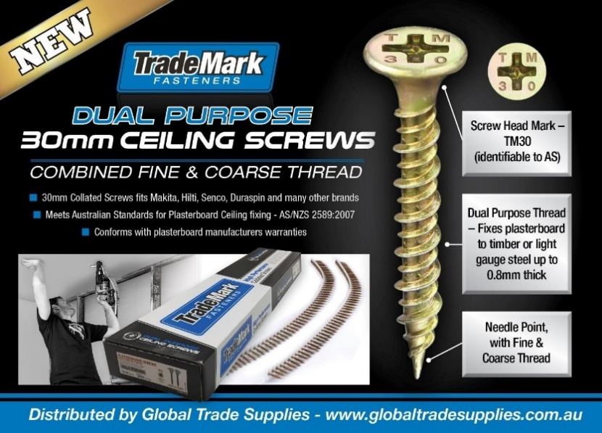

Features

• Dual Purpose Thread – Fixes plasterboard to timber or light gauge steel up to 0.8mm thick
• Needle Point, with Fine & Coarse Thread
• Meets Australian Standard for Plasterboard Ceiling fixing.
• Conforms to plasterboard manufacturers warranties.
• Screw Head Mark – TM30 (Easily identifiable to meet Australian Standards)

Short Code | Description | Product Code | Barcode | Preferred Order Qty
CS30 | COLLATED SCREWS PLASTER #6 X 30MM  DUAL PURPOSE THREAD NP PH2 YZ 1000 PCS | TMCPDP30YZ | 9350149002894 | 10
LS130 | LOOSE SCREWS PLASTER #6 X 30MM  DUAL PURPOSE THREAD NP PH2 YZ 1000 PCS | TMLPDP30YZ | 9350149003631 | 12

